Download firebase plugins from this link

<https://firebase.google.com/docs/unity/setup>

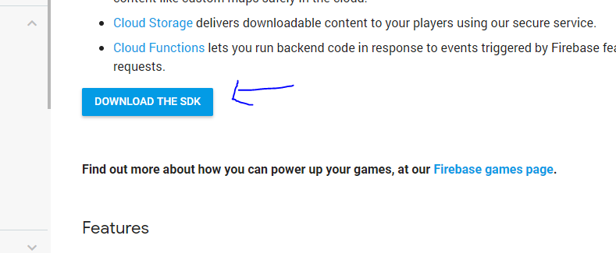

After downloading the zip file, extract the SDK anywhere in your drive. You’ll see 9 different Firebase packages but we don’t need all of these. Import 3 packages “FirebaseAuth”, “Firebase Database” and “Firebase Storage”. See below screenshot

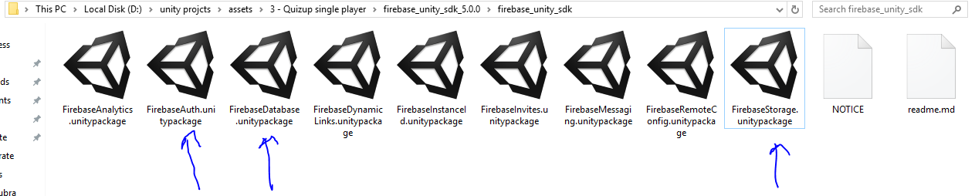

After adding these 3 packages in your project, you are now good to go Without any errors.

Refer to documentation.doc file for further making changes In the project according to your use.